LECTURE 5
DES THEORY
*** use the slides as well***
1. Modern Block Ciphers
Definition
Modern block ciphers are cryptographic algorithms that encrypt data in fixed-size blocks (such as 64 or 128 bits) using a secret key.
Key Characteristics
- Operate on entire blocks of data at once
- Use the same key for encryption and decryption (symmetric encryption)
- Designed to be efficient and secure
- Widely used in practical applications like secure communication and data storage
Purpose
- Provide confidentiality of data
- Can also support authentication mechanisms
Example
A plaintext block of 64 bits is transformed into a ciphertext block of 64 bits using a key.

2. Block vs Stream Ciphers
Block Ciphers
- Process data in fixed-size blocks
- Each block is encrypted separately
- Require the entire block before processing
Stream Ciphers
- Process data one bit or byte at a time
- Encrypt data as a continuous stream
- Do not require waiting for a full block
Key Differences
- Block ciphers work on chunks; stream ciphers work continuously
- Block ciphers are more widely used and better studied
- Block ciphers support more applications
Conclusion
Block ciphers are generally preferred due to their flexibility and stronger analytical foundation.

3. Shannon’s Guide to Good Ciphers
Proposed by Claude Shannon
Principles of Good Cipher Design
- The level of security should match the importance of the data
- The encryption algorithm and key system should not be overly complex
- Implementation should be simple and efficient
- Errors during encryption should not spread significantly
- Ciphertext size should not be much larger than plaintext
Importance
These principles guide the design of secure, practical, and efficient encryption systems.

4. Claude Shannon and Substitution-Permutation Ciphers
Introduced by Claude Shannon
Concept
Substitution-Permutation (S-P) networks are a fundamental design model for modern block ciphers.
Components
- Substitution (S-box): Replaces input bits with different bits
- Permutation (P-box): Rearranges the bits
Key Idea
Security is achieved by repeatedly applying substitution and permutation operations in multiple rounds.
Confusion and Diffusion
- Confusion: Makes the relationship between key and ciphertext complex
- Diffusion: Spreads the influence of each plaintext bit across many ciphertext bits
Importance
S-P networks form the theoretical foundation of many modern encryption algorithms, including DES.

5. Diffusion and Confusion
Diffusion
Diffusion refers to spreading the statistical structure of the plaintext over the ciphertext.
Key Idea
- A single change in plaintext affects many bits in ciphertext
- Hides patterns present in the original data
Purpose
- Prevents attackers from identifying patterns in plaintext
Confusion
Confusion refers to making the relationship between the ciphertext and the encryption key as complex as possible.
Key Idea
- Small change in key → large unpredictable change in ciphertext
- Achieved using substitution techniques
Purpose
- Prevents attackers from deducing the key
Summary
- Diffusion hides plaintext patterns
- Confusion hides key relationships
- Both are essential for strong encryption

6. Block Cipher Principles
Definition
Block cipher principles describe how modern symmetric encryption algorithms are structured and operate.
Key Concepts
- Most block ciphers use a Feistel structure
- Encryption is done in multiple rounds
- Each round applies substitution and permutation
- The cipher behaves like a large complex substitution
Encryption and Decryption
- Same algorithm is used for both
- Only the order of keys is reversed during decryption
Purpose
- To achieve high security through repeated transformations

7. Ideal Block Cipher
Definition
An ideal block cipher is a theoretical model where every possible plaintext is mapped to a completely random and unique ciphertext.
Key Characteristics
- Each input has a unique output
- Mapping is completely random
- No patterns can be detected
Limitation
- Not practical to implement due to extremely large complexity
Importance
- Serves as a benchmark for designing real ciphers like DES
- Real systems try to approximate this ideal behavior

8. Feistel Cipher Structure
Definition
The Feistel cipher structure is a symmetric encryption design that divides the input data block into two halves and processes them through multiple rounds.
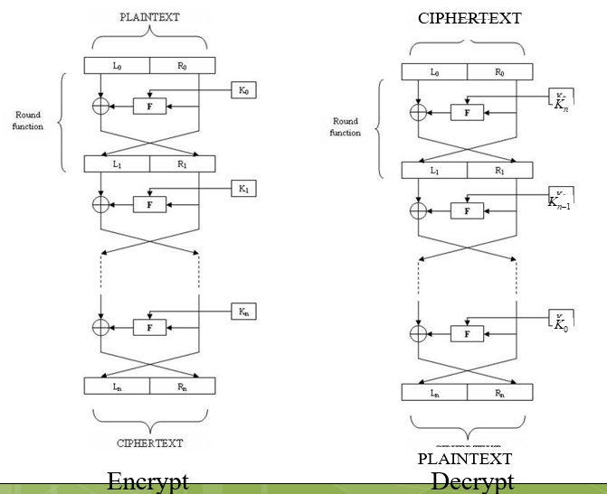
Working Principle
- Input block is divided into left (L) and right (R) halves
- In each round:
  - A function is applied to the right half using a subkey
  - Output is XORed with the left half
  - Halves are swapped
Key Feature
- Same structure is used for both encryption and decryption
- Only the order of keys is reversed
Importance
- Provides a practical way to build secure block ciphers
- Used in DES and many other algorithms

9. Feistel Network Structure
Definition
A Feistel network is the repeated application of the Feistel cipher structure over multiple rounds.
Key Characteristics
- Consists of several rounds (e.g., 16 in DES)
- Each round improves security
- Combines substitution and permutation operations
Encryption Process
- Data passes through multiple rounds
- Each round modifies half of the data
Decryption Process
- Same steps as encryption
- Round keys are applied in reverse order
Importance
- Ensures security through repeated transformations
- Makes implementation efficient

10. Feistel Cipher Design Elements
Definition
These are the parameters that determine the strength and performance of a Feistel cipher.
Main Elements
- Block size
  - Larger size increases security but reduces speed
- Key size
  - Larger key makes brute-force attacks harder
- Number of rounds
  - More rounds increase security
- Subkey generation algorithm
  - Generates round keys from the main key
- Round function
  - Core operation that provides confusion and diffusion
- Efficiency
  - Should allow fast encryption and decryption
- Ease of analysis
  - Should be testable for security
Importance
Proper selection of these elements ensures a balance between security and performance.
11. General Structure of DES
Components
- Initial permutation (IP)
- 16 Feistel rounds
- Final permutation (inverse of IP)
Inside Each Round
- Expansion of data
- XOR with round key
- Substitution using S-boxes
- Permutation using P-box
Key Idea
Security is achieved by repeating these operations multiple times.

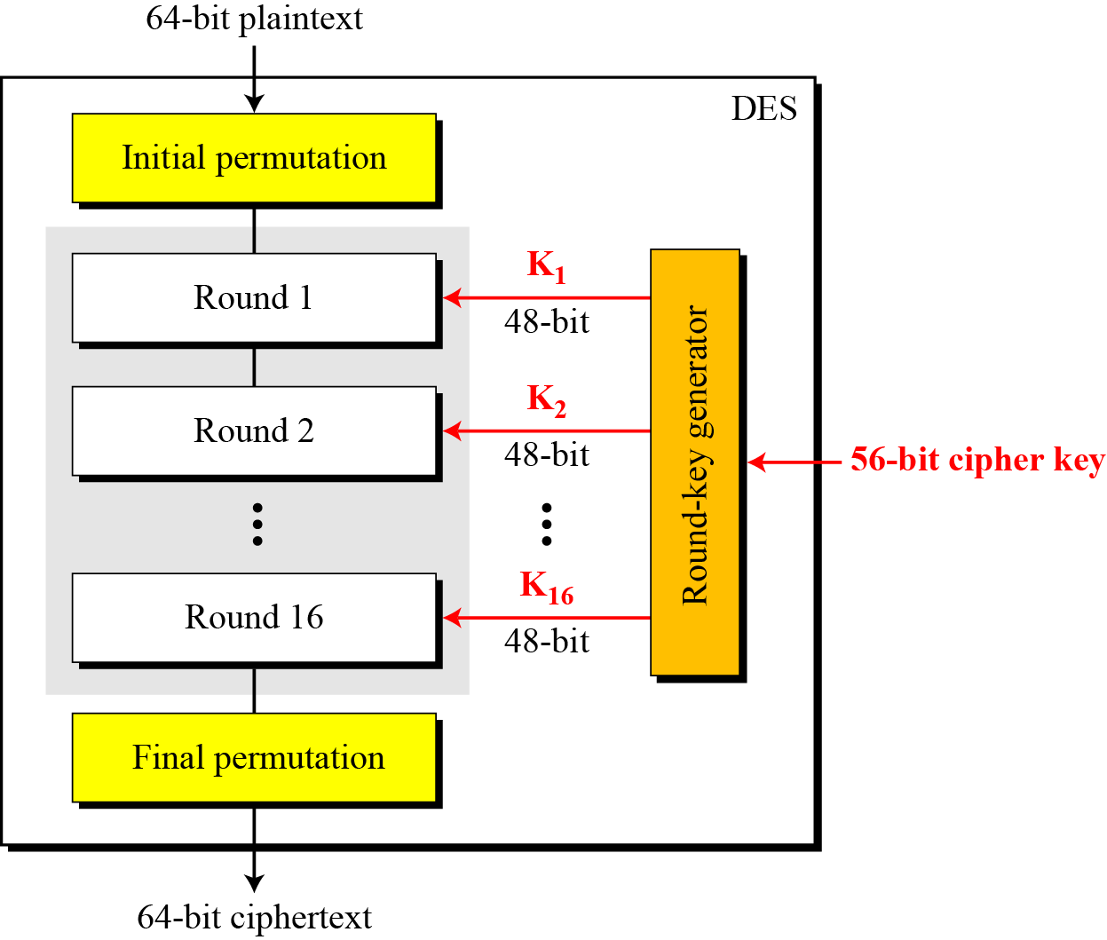
12. DES STRUCTURE
Detailed View
DES consists of three main stages:
- Initial Permutation
- Rearranges input bits
- No direct impact on security
- 16 Feistel Rounds
- Core of DES
- Each round includes:
  - Expansion
  - XOR with key
  - Substitution (S-boxes)
  - Permutation (P-box)
- Final Permutation
- Inverse of initial permutation
- Produces final ciphertext
Important Note
- The strength of DES lies mainly in the 16 rounds, not in the permutations

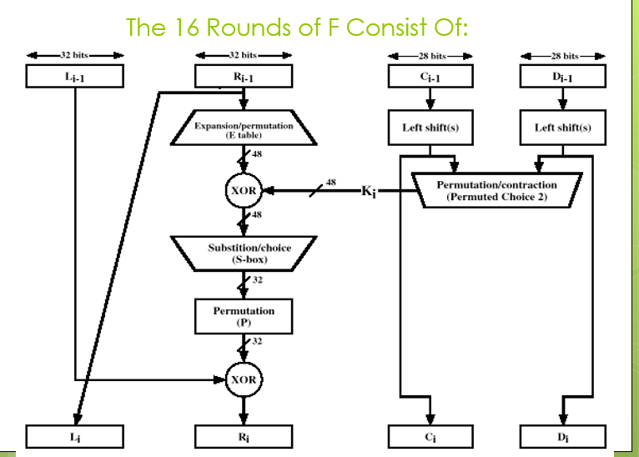

13. Permutation in DES (P-box)
Definition
Permutation is a process of rearranging the positions of bits according to a predefined table.
Types of Permutations in DES
1. Initial Permutation (IP)
- Applied at the beginning of DES
- Rearranges all 64 input bits using a fixed table
2. Final Permutation (FP)
- Applied at the end of DES
- It is the inverse of the initial permutation
Key Property
- Initial and final permutations cancel each other
- They do not add security, only rearrange bits
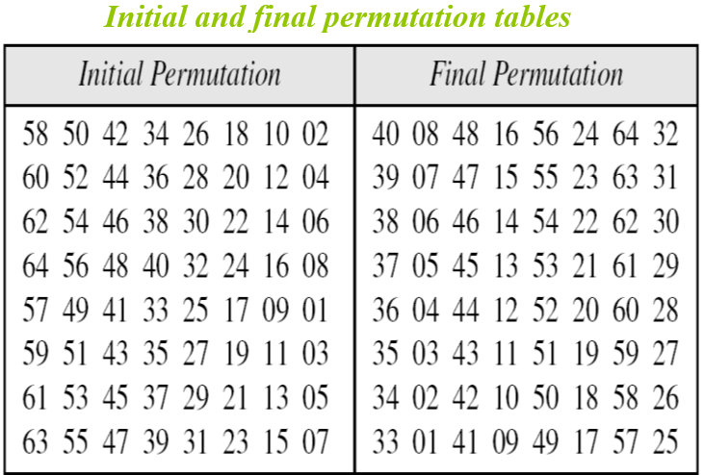
How Permutation Works (Using Table)
From your slide:
- Each number represents the new position of a bit
- Example:
  - If position 1 contains value 58 → output bit 1 = input bit 58
Example Insight
- Bit 25 → becomes bit 64
- Bit 63 → becomes bit 15
Purpose of Permutation
- Spreads bits across positions (diffusion)
- Ensures bits from one position influence many positions later
Other Permutations in DES
- Expansion Permutation (32 → 48 bits)
- Straight Permutation (after S-box)

14. S-Box Substitution in DES
Definition
S-box (Substitution box) is a component that replaces input bits with different output bits using a lookup table.
Structure of S-box
- DES uses 8 S-boxes
- Each S-box:
  - Input: 6 bits
  - Output: 4 bits
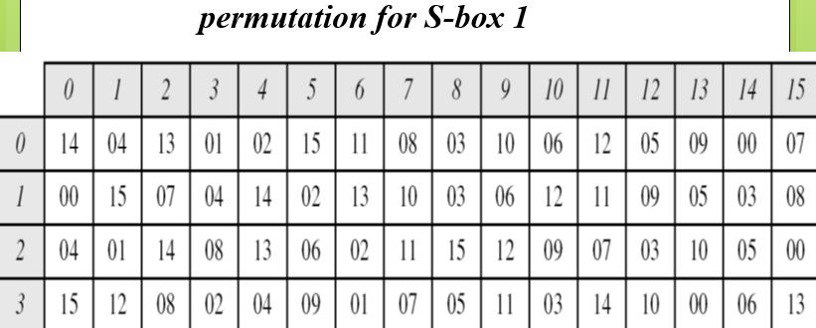
How S-box Works (Using Your Table)
Given a 6-bit input:
Step 1: Find Row
- Use 1st and 6th bits
- Combine them → form a 2-bit number
Step 2: Find Column
- Use middle 4 bits
Step 3: Lookup Table
- Find value at (row, column)
- Convert result to 4-bit binary
Example (from slide)
Input: 100011
- Row = first & last bits = 11 → 3
- Column = middle bits = 0001 → 1
- Output = value at row 3, column 1 = 12 → 1100
Key Function
- S-box performs substitution (non-linear transformation)
- This is where actual “mixing” happens
Purpose of S-box
- Provides confusion
- Makes relationship between input and output complex
- Prevents attackers from predicting patterns
Important Properties
- Non-linear (very important for security)
- Reduces 48 bits back to 32 bits (after expansion)
- Each S-box works independently

15. DES Analysis
Definition
DES analysis refers to the study of how effectively the Data Encryption Standard achieves security through its internal structure, operations, and resistance to attacks.
Core Idea
DES is designed using a Feistel structure with 16 rounds, where each round applies substitution and permutation to progressively transform plaintext into ciphertext.
Key Features Observed in Analysis
1. Repeated Rounds
- DES uses 16 rounds, each adding complexity
- Each round increases randomness and security
- Multiple rounds ensure that the final output is highly mixed
2. Confusion and Diffusion
- Confusion is achieved using S-boxes (non-linear substitution)
- Diffusion is achieved using permutations (P-boxes)
- Together, they hide both:
  - Patterns in plaintext
  - Relationship between key and ciphertext
3. Bit Dependency
- After several rounds, each output bit depends on many input bits
- This ensures that no direct relationship can be traced
4. Random-Like Output
- Ciphertext produced by DES appears statistically random
- Even structured input loses its pattern
Purpose of DES Analysis
- To evaluate resistance against cryptographic attacks
- To verify whether DES behaves close to an ideal block cipher
- To study properties like avalanche effect and completeness

16. Avalanche Effect and Completeness
Avalanche Effect
Definition
The avalanche effect is a property where a small change in input (plaintext or key) causes a large and unpredictable change in output (ciphertext).
Key Characteristics
- Changing even one bit in plaintext or key significantly alters the ciphertext
- Ideally, about 50% of the output bits change
Example Insight
- In DES, changing a single bit in plaintext can result in around half of the ciphertext bits flipping
Importance
- Prevents attackers from predicting output changes
- Ensures high sensitivity to input variations
- Strengthens resistance to statistical and differential attacks
Completeness
Definition
Completeness means that each bit of the ciphertext depends on multiple bits of the plaintext and key.
Key Characteristics
- No output bit depends on only one input bit
- All bits are interconnected through multiple rounds
Importance
- Prevents leakage of partial information
- Ensures that the cipher behaves as a complex system
- Increases overall security
Combined Significance
- Avalanche effect ensures large changes from small inputs
- Completeness ensures full dependency across bits
- Together, they make DES resistant to pattern-based attacks

17. Design Criteria
Definition
Design criteria refer to the principles and components used to construct DES in a way that ensures both security and efficiency.
Main Design Components
1. S-Boxes (Substitution Boxes)
- Provide confusion
- Perform non-linear transformation of data
- Convert 6-bit input into 4-bit output
- Make relationship between input and output complex
2. P-Boxes (Permutation Boxes)
- Provide diffusion
- Rearrange bits to spread their influence
- Ensure that output bits depend on multiple input bits
3. Number of Rounds
- DES uses 16 rounds
- Each round increases complexity
- More rounds → better security (but slower performance)
4. Round Function
- Combines expansion, XOR with key, substitution, and permutation
- Central to achieving both confusion and diffusion

18. DES Weaknesses
Definition
DES weaknesses refer to the limitations in the algorithm that reduce its security against modern cryptographic attacks.
Major Weaknesses
1. Small Key Size
- DES uses a 56-bit key
- Vulnerable to brute-force attacks
- Modern computers can try all possible keys in feasible time
2. Advances in Computing
- Increased processing power makes key search faster
- Specialized hardware can break DES efficiently
3. Susceptibility to Cryptanalysis
- DES is theoretically vulnerable to:
  - Differential cryptanalysis
  - Linear cryptanalysis
- Though difficult in practice, they expose structural weaknesses

19. Weaknesses in Cipher Design
Definition
These are structural limitations in the design of DES that can reduce its overall security.
Key Issues
- Limited key size reduces security strength
- Certain patterns may emerge under specific conditions
- Dependence on fixed structures (like S-boxes and P-boxes)
Impact
- Makes the cipher less secure compared to modern standards
- Limits long-term usability

20. Weaknesses in S-boxes
Role of S-boxes
- Provide confusion through non-linear substitution
Possible Weaknesses
- If not properly designed:
  - Output patterns may be predictable
  - Easier to perform cryptanalysis
In DES
- S-boxes were carefully designed to resist attacks
- However, secrecy of design initially caused suspicion
Impact
- Weak S-boxes can compromise entire cipher security

21. Weaknesses in P-boxes
Role of P-boxes
- Provide diffusion by spreading bits
Possible Weaknesses
- Poor permutation leads to:
  - Insufficient spreading of bits
  - Weak avalanche effect
Impact
- Reduces mixing of data
- Makes patterns easier to detect

22. Weaknesses in Key
Key Issues
1. Small Key Size
- Only 56 bits → easy brute-force
2. Weak Keys Exist
- Some keys produce predictable or repetitive results
3. Key Schedule Limitations
- Subkey generation may not provide enough randomness in rare cases
Impact
- Reduces effective key strength
- Makes attacks easier

23. Semi-Weak Keys
Definition
Semi-weak keys are pairs of keys that behave like opposites.
Simple Idea
- If you use Key A to encrypt data
- Then using Key B will undo it (decrypt it)
So basically:
- Key A and Key B are linked
- One reverses the effect of the other
Easy Example (Conceptual)
- Plaintext → (Key A) → Ciphertext
- Ciphertext → (Key B) → Original Plaintext
Characteristics
- Always come in pairs (two keys together)
- Both keys generate similar patterns during encryption
Why This is a Problem
- These keys are not fully independent
- They reduce the total number of “strong” keys
- In theory, attackers can take advantage of this behavior

24. Weak Keys Probability
Definition
The probability of randomly selecting weak or semi-weak keys from the total key space.
Key Facts
- DES key space = $2^{56}$possible keys
- Weak and semi-weak keys are very few (total ≈ 64)
Probability
- Extremely low (almost negligible)
Conclusion
- Although weak keys exist, the chance of selecting one randomly is practically zero

